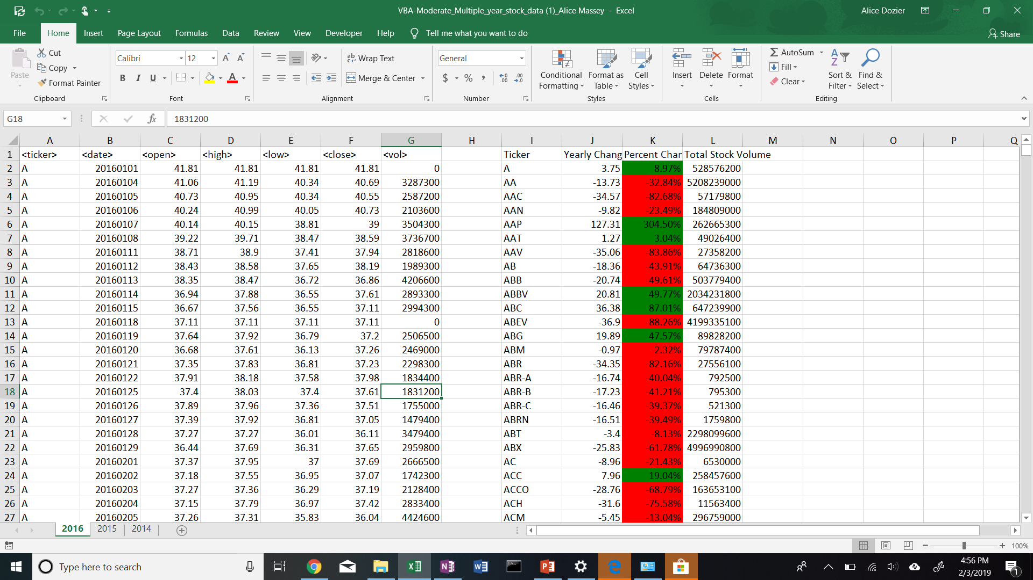

VBA MODERATE CODE:

Sub TickerVolume()

Dim ticker As String

Dim vol As Double

Dim percentchange As Double

vol = 0

Dim Summary_Table_Row As Integer

Dim year_open As Double

Dim year_close As Double

Dim yearly_change As Double

Cells(1, 9).Value = "Ticker"

Cells(1, 10).Value = "Yearly Change"

Cells(1, 11).Value = "Percent Change"

Cells(1, 12).Value = "Total Stock Volume"

Summary_Table_Row = 2

For i = 2 To 797712

If year_open = 0 Then

year_open = Cells(i, 3).Value

End If

If Cells(i - 1, 1) = Cells(i, 1) And Cells(i + 1, 1).Value <> Cells(i, 1).Value Then

year_close = Cells(i, 6).Value

yearly_change = year_close - year_open

percent_change = yearly_change / year_open

ticker = Cells(i, 1).Value

vol = vol + Cells(i, 7).Value

Range("I" & Summary_Table_Row).Value = ticker

Range("J" & Summary_Table_Row).Value = yearly_change

Range("K" & Summary_Table_Row).Value = percent_change

Range("K" & Summary_Table_Row).NumberFormat = "0.00%"

If Range("K" & Summary_Table_Row).Value < 0 Then

Range("K" & Summary_Table_Row).Interior.Color = RGB(255, 0, 0)

Else

Range("K" & Summary_Table_Row).Interior.Color = RGB(0, 128, 0)

End If

Range("L" & Summary_Table_Row).Value = vol

Summary_Table_Row = Summary_Table_Row + 1

vol = 0

Else

vol = vol + Cells(i, 7).Value

End If

Next i

End Sub